Joel Chavali

1 August 2017

Molecular Dynamics

In this simulation, I modeled Exercise 1 (Input.pdb) at a target of 310 for 30,000 time steps. The model reached equilibrium at time step 6000 and had an average of 309.835 K for the rest of the time steps.

The graph below shows the stabilization of temperature at time step 6,000. The average temperature is 309.835 K and the standard deviation is 3.038 for temperature.

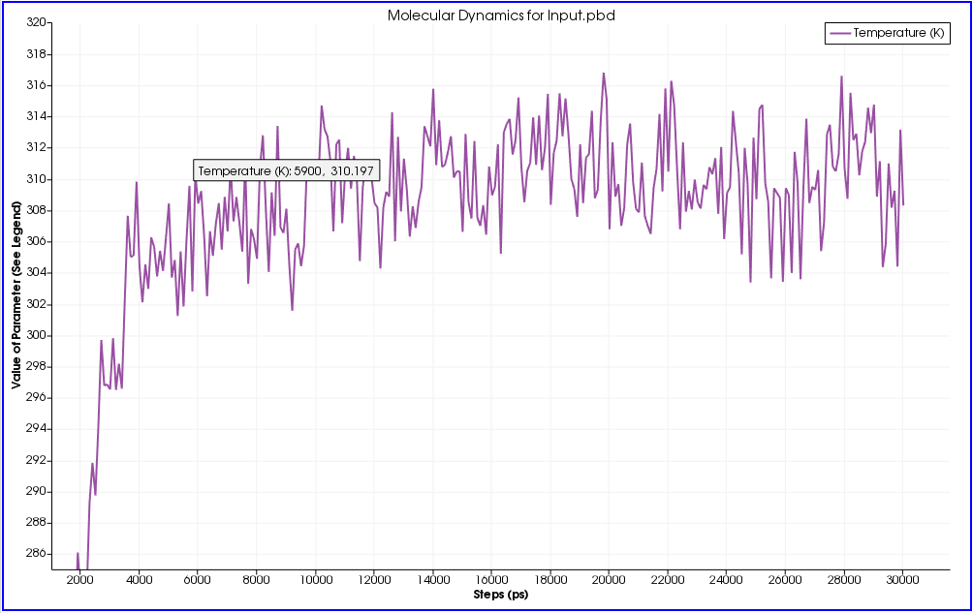  
The graph below shows the temperature and the kinetic energy stabilizing at time step 6,000 and verifies that temperature is correctly reflecting its relationship with kinetic energy.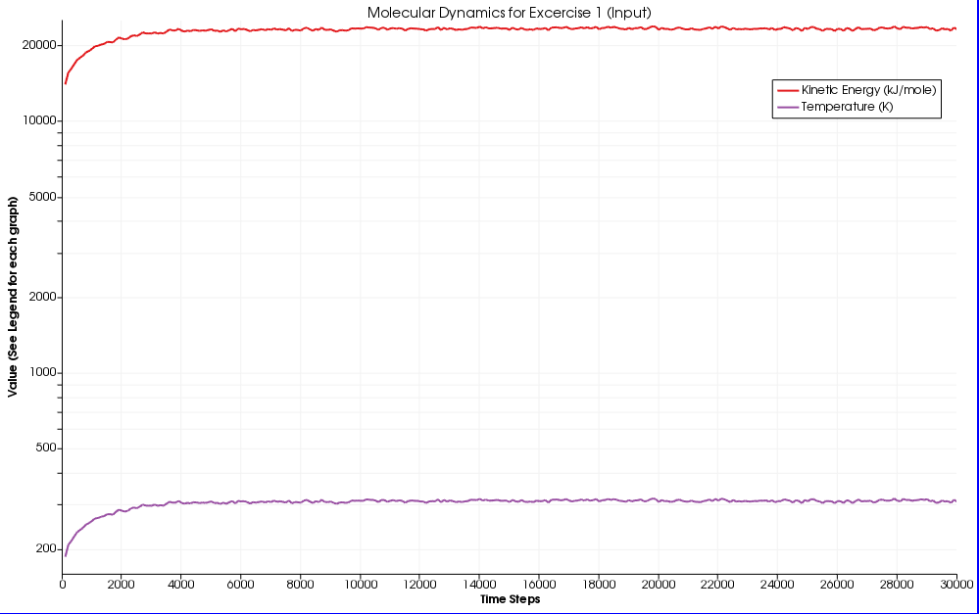

As the time goes on the energy of the system balances out and remains stable with the energy remaining stable after the 6000 time step mark. 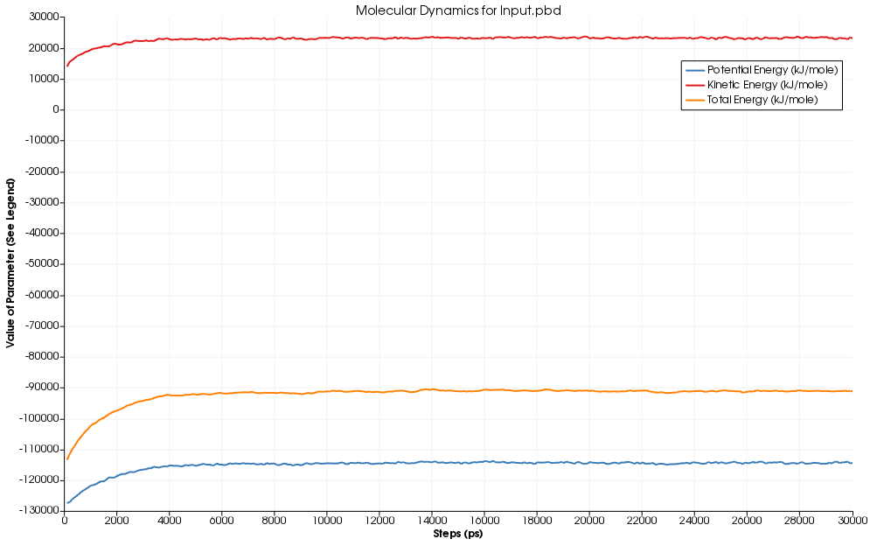

The density graph displays that the molecule remained spatially stable across all time steps which confirms the stability of the molecule at 310 K.